**Snow crab data entry specifications:**

**Table 1:** Tow-level data fields (entered only once per tow).

|  |  |  |  |
| --- | --- | --- | --- |
| **Field** | **Format** | **Type** | **Examples** |
| Date | yyyy-mm-dd | required | 2023-09-01 |
| Tow number | Integer | required | 1, …, 20 |
| Tow ID | Character | required | “GP002F” , “GP123R2” |
| Sampler | Character | required | “Yves Laroque” |

**Table 2:** Crab-level data fields.

|  |  |  |  |  |
| --- | --- | --- | --- | --- |
| **Field** | **Format** | **Type** | **Examples** | **Description** |
| Crab number | Integer | Automatically generated | 1, 2, 3, … | Incremental crab numbers |
| Sex | {0,1,2,3} | Required |  |  |
| Shell condition | {1,2,3,4,5} | required |  |  |
| Carapace width | Real [0-160] | required | 112.59 mm | From digital caliper |
| Claw height | Real [0-45] | required for males | 35.78 mm | From digital caliper |
| Missing legs | Char[10] | optional, see Table 3 | “***12**1***” |  |
| Gonad color | {1,2,3,4} | optional for females |  |  |
| Egg color | {1,2,3,4,5} | optional for females |  |  |
| Eggs remaining | {0,1,2,3,4} | optional for females |  |  |

**Table 3:** Example of missing and regenerating legs table. Note that missing and regenerating legs are mutually exclusive categories. Inputs in the table correspond to pattern “*2*1****11*.

|  |  |  |  |  |  |  |  |  |  |  |
| --- | --- | --- | --- | --- | --- | --- | --- | --- | --- | --- |
|  | **Left** | | | | | **Right** | | | | |
| **Type** | **L1** | **L2** | **L3** | **L4** | **L5** | **R1** | **R2** | **R3** | **R4** | **R5** |
| **Missing** |  |  |  | **x** |  |  |  |  | **x** | **x** |
| **Regenerating** |  | **x** |  |  |  |  |  |  |  |  |

**Figure 1:** Sample form for **male** snow crab from FileMaker Pro data entry system.

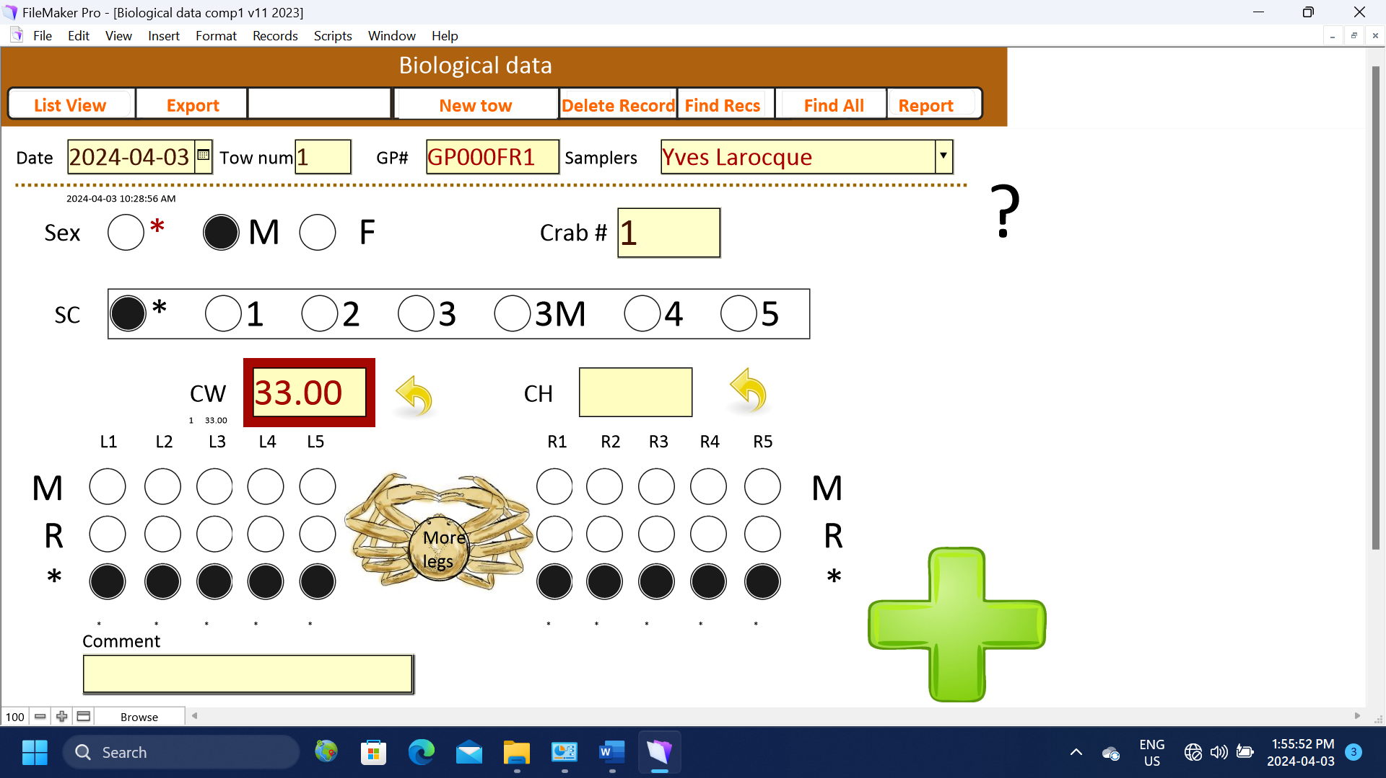

**Figure 2:** Sample form for **female** snow crab from FileMaker Pro data entry system.

